Famous Americans in Scratch
Brief Overview:  In this lesson, students will write an algorithm/ program that animate a Famous Person. |  |  | Target Grade Levels:  2-5
Time:
1 hour
Computer Science SOLs:  Target SOLs: CS 2.1, 2.2, 2.3, 3.1, 3.2, 3.3, 4.1, 4.2, 4.3, 5.1, 5.2, 5.3, | Content SOLs:  Target SOLs: HSS 2.4, 3.2, 3.3, 3.4, VS.5, VS.6, VS.9, 5.1  *Notes:  3rd Grade use people from ancient civilizations.  4th Grade use Famous Virginians.  5th Grade use People Around the World
Objectives:
- Students will:
  - Create an algorithm.
  - Create a speech with at least two facts about a major person.

Materials/ Prep:  - Scratch (student logins are helpful)  - Run copies of student directions  Scratch is a free program: https://scratch.mit.edu  Teachers can create teacher accounts here: https://scratch.mit.edu/educators  (scroll down) |  | CS Vocabulary:  - Algorithm – A list of steps that you can follow to finish a task.
Credits and Links:
Images from https://www.teacherspayteachers.com/Store/Reading-Teachers-Backpack

Famous Americans in Scratch
Step 1: Login to Scratch and open the Project.
Login to Scratch.
Open the Famous Americans Template
Choose See inside. 
Choose remix  to copy the project to your own account.

Step 2: Pick Your Costume
Click on Costumes Tab

Choose a Famous American
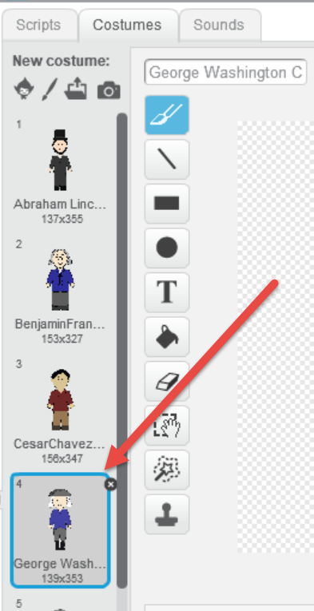
Step 3: Add code to make the Famous American Speak
Click on the Scripts Tab.
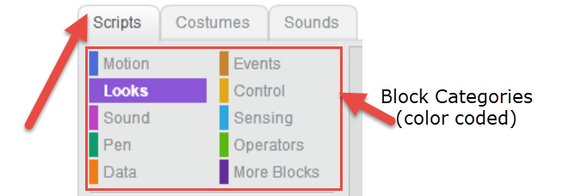
Add at least three say for 2 seconds blocks (under Looks category).
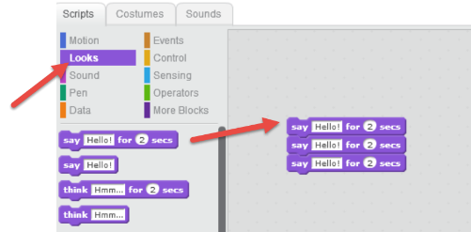
Add text to the say for 2 seconds blocks to make your Famous Person speak.
- Have your person introduce his/herself.
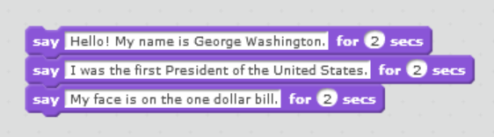
- Have your person give at least 2 facts about him/herself.

*Example only – your text will be different.*

Step 4: Add code to start the program
Add a when flag is clicked block to allow the user to easily start the program.
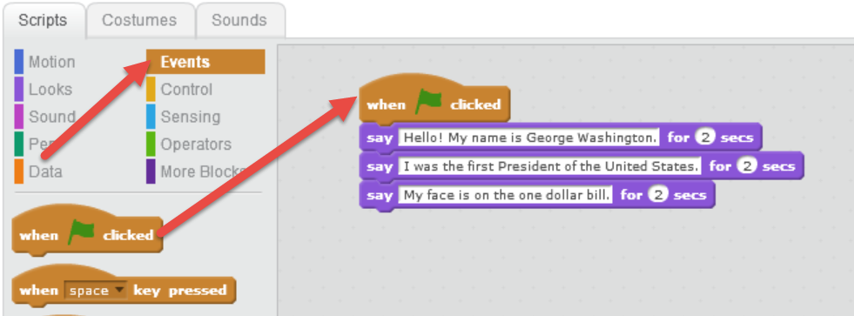
Step 5: Test your code
To test your code, click the green flag. 
Challenge/Extensions:
Add a background.  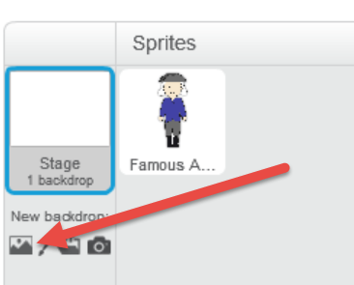 | Use the following code to make your Famous American move!  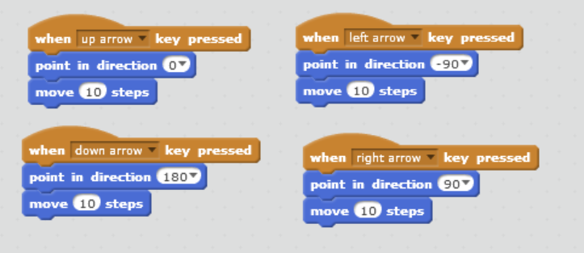
At the beginning of the project, have students draw their own Famous Person Sprite.
