Famous Americans in Scratch
Brief Overview:  In this lesson, students will write an algorithm/ program that animates a Famous Person. |  |  | Target Grade Levels:  2-5
Time:
1 hour
Computer Science SOLs:  Target SOLs: CS 2.1, 2.2, 2.3, 3.1, 3.2, 3.3, 4.1, 4.2, 4.3, 5.1, 5.2, 5.3, | Content SOLs:  Target SOLs: HSS 2.4, 3.2, 3.3, 3.4, VS.5, VS.6, VS.9, 5.1  *Notes:  3rd Grade use people from ancient civilizations.  4th Grade use Famous Virginians.  5th Grade use People Around the World
Objectives:
- Students will:
  - Create an algorithm.
  - Create a speech with at least two facts about a major person.

Materials/ Prep:  - Scratch (student logins are helpful)  - Run copies of student directions  Scratch is a free program: https://scratch.mit.edu  Teachers can create teacher accounts here: https://scratch.mit.edu/educators  (scroll down) |  | CS Vocabulary:  - Algorithm – A list of steps that you can follow to finish a task.
Credits and Links:
Images from https://www.teacherspayteachers.com/Store/Reading-Teachers-Backpack

Famous Americans in Scratch
Step 1: Login to Scratch and open the Project.
Login to Scratch.
Open the Famous Americans Template
Choose See inside. 
Choose remix to copy the project to your own account.

Step 2: Pick Your Costume
Click on Costumes Tab.

Choose a Famous American
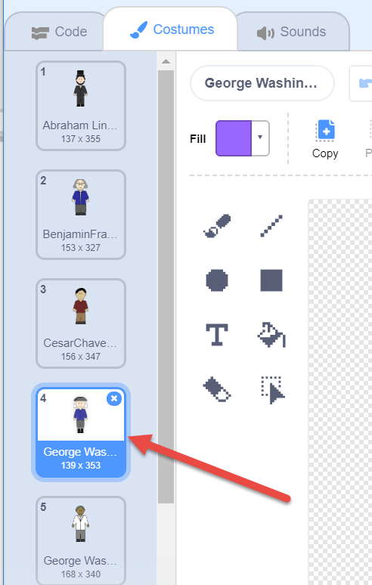
Step 3: Add code to make the Famous American Speak
Click on the Code Tab.

Click on Add Extension.
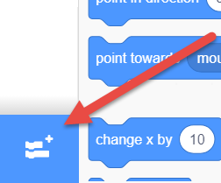
Choose Text to Speech
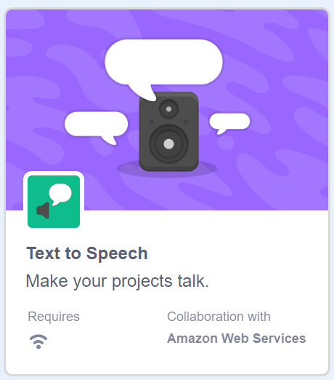
Now you should have a text to speech category in your Code section.
Add the set voice to block and the speak block in the code area.
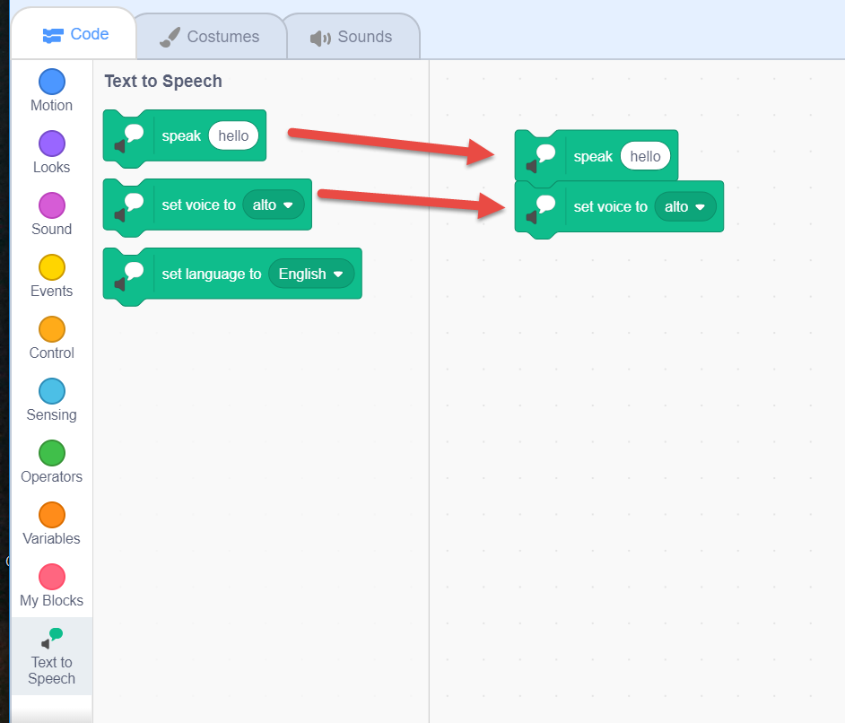
Add text to the speak block to make your Famous Person speak. You can type all the facts in one block or add another block to make it easier to read.
- Have your person introduce his/herself.
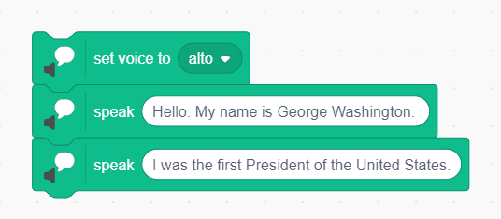
- Have your person give at least 2 facts about him/herself.

*Example only – your text will be different.*

Step 4: Add code to start the program
Add a when flag is clicked block to allow the user to easily start the program.
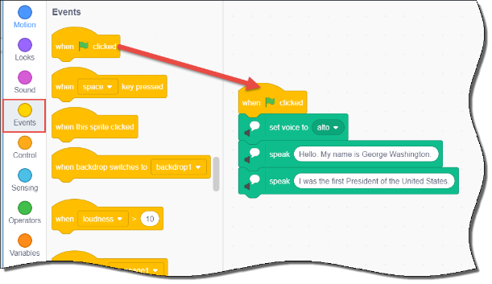
Step 5: Test your code
To test your code, click the green flag. 
After listening to your person speak, you may want to go back and change the type of voice he/she has.
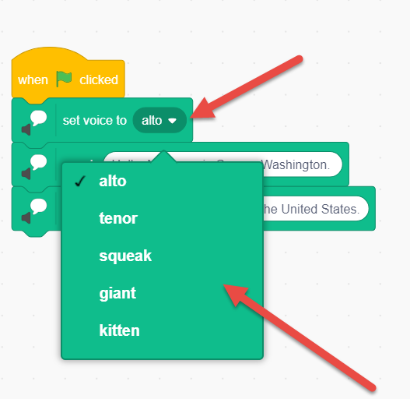
Challenge/Extensions:
Add a stage/backdrop.  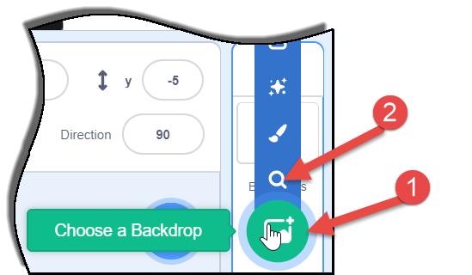 | Use the following code to make your Famous American move!  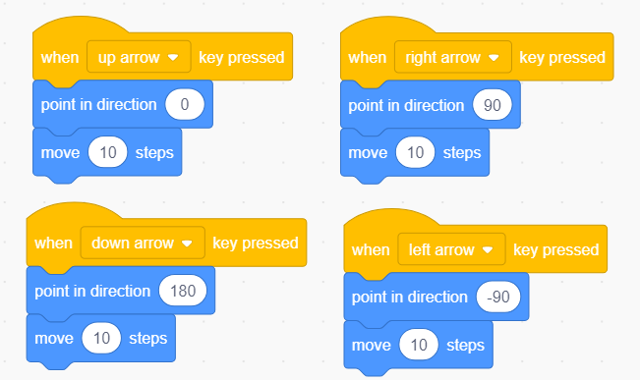
At the beginning of the project, have students draw their own Famous Person Sprite.
